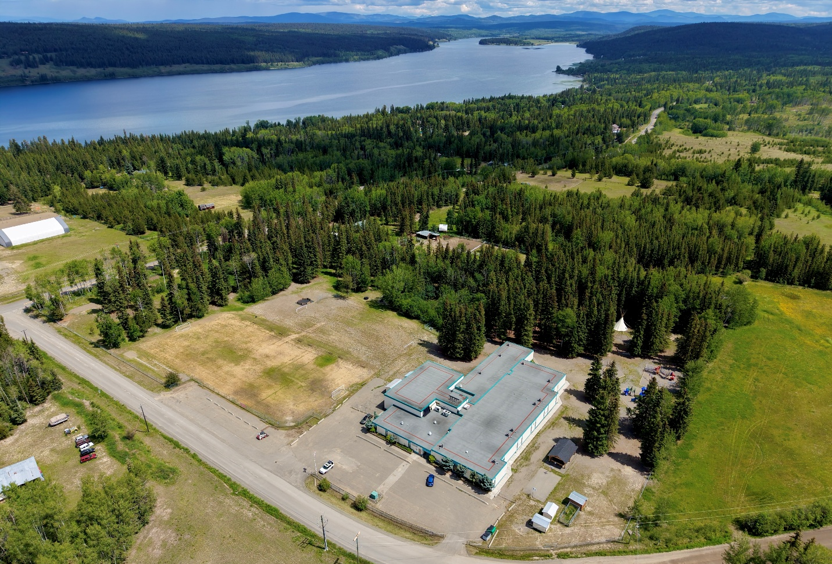

Horse Lake Elementary - 2026-2027 School Year

Good morning Parents and Caregivers,
I hope everyone has had a wonderful summer break and is looking forward to returning to school next week! We have had some staffing changes over the summer and are still awaiting staffing finalization from the School District in the coming days. I look forward to seeing our returning students and welcoming our new families to the school community next week.

School Office Hours – September 1st – 4th
Our new Secretary, Ms. Cheryl Bird, starts her year on September 1st, with office hours from 12:00 noon until 3:00 p.m. From September 2nd – 4th, office hours will be from 10:00 a.m. – 2:00 p.m.

The First Week Back:
Tuesday, September 8th is the District Planning Day. Students do not attend, but all staff will be at the school taking part in professional learning sessions in the morning and will congregate with all south end staff in the afternoon at Centennial Park for some Indigenous learning.
Wednesday, September 9th is a half-day for all students, except for our new kindergarten students who do not attend this week. The morning busses will run at their regular times, but school dismissal is 10:50 a.m., and busses will depart the school shortly thereafter. Parents/caregivers of kindergarten students will have their scheduled meetings with Mr. Foote from Wednesday, September 9th through to Friday, September 11th.
Thursday, September 10th and Friday, September 11th are full days for our grade 1-7. At 7:55 a.m., there is a bell that signifies that students can enter the building. The school day begins with the first bell at 8:10 a.m., with students expected to be in class by 8:15 a.m. Recess begins with a bell at 9:50 a.m. and students return to class at 10:05 a.m. The lunch eating period begins at 11:20 a.m. and students are dismissed at 11:35 a.m. They return to class at 12:20 p.m. The school day ends with the 2:25 p.m. bell to waiting buses.
Monday, September 14th and Tuesday, September 15th are half days for our kindergarten students, with half the class attending in the morning, and the other half in the afternoon, and switching sessions on the second day.
School Supplies:
Primary students from Kindergarten to Grade 3 are provided with school supplies through the school. There is a school supply fee of $45.00 per student, which we would like to collect by Monday, September 15th. This can be paid by cheque to Horse Lake Elementary, or with cash, exact change if possible. We cannot accept electronic payments. If this fee is a hardship for your family, please contact the school.
Attached to this email you will find the school supply lists and School Calendar for the year, which shows statutory holidays and professional development days for the year.
Class lists will be posted at the school once we are in a position to finalize everything, hopefully by the afternoon of Tuesday, September 8th. Students will report to their new class on September 9th for the first full day of school.
Sincerely,
Murray Helmer, Principal
murray.helmer@sd27.bc.ca

